UNESCO Falconry inscription pictures at glance...
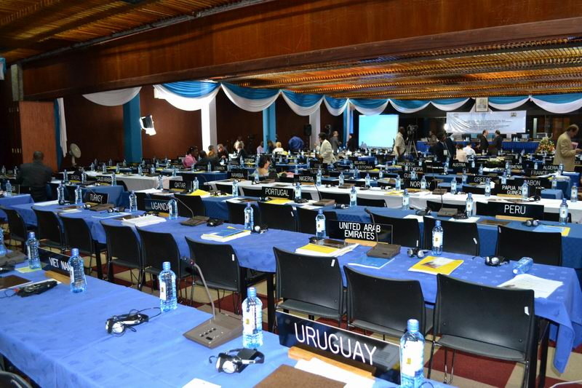  1 | 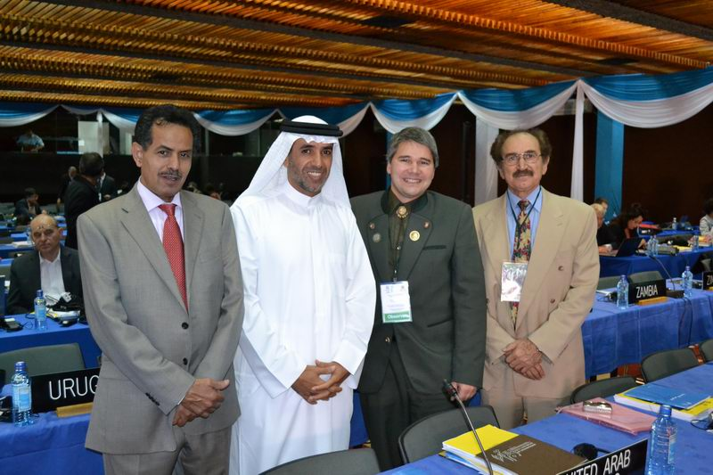  2 | 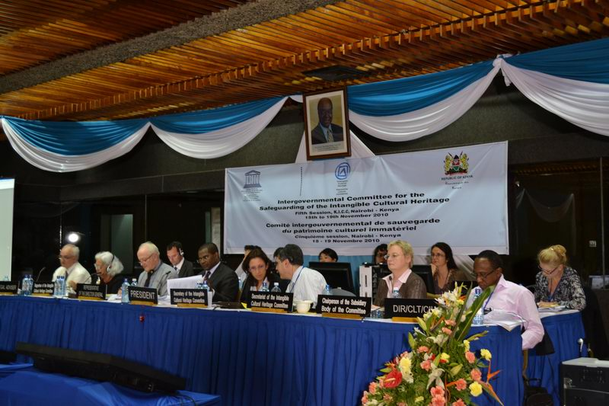  3 | 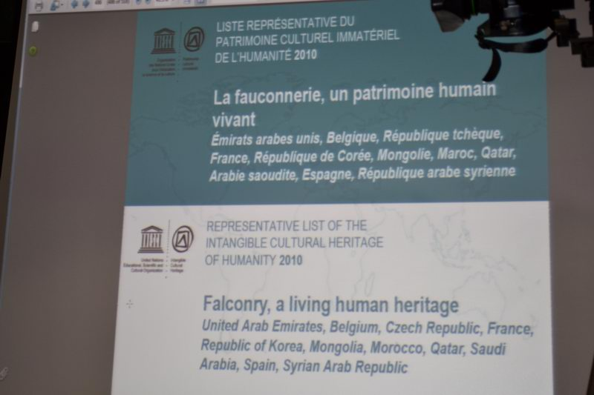  4
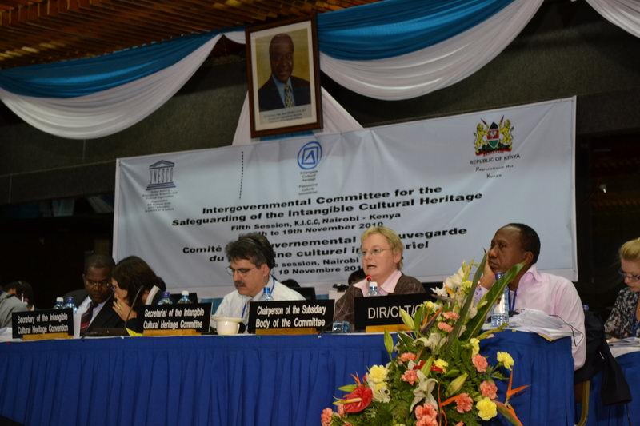  5 | 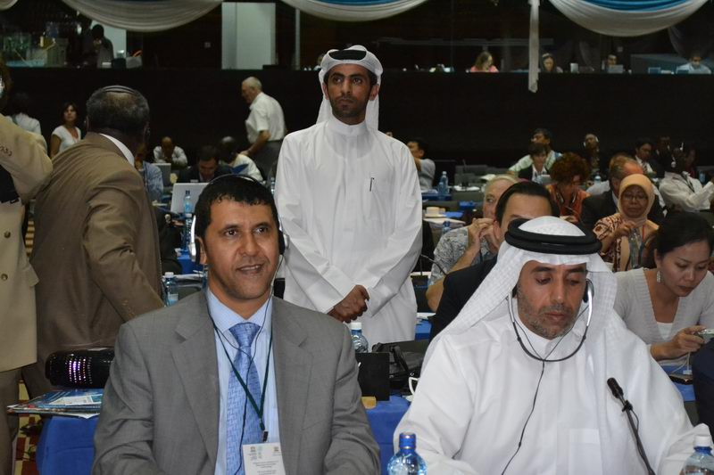  6 | 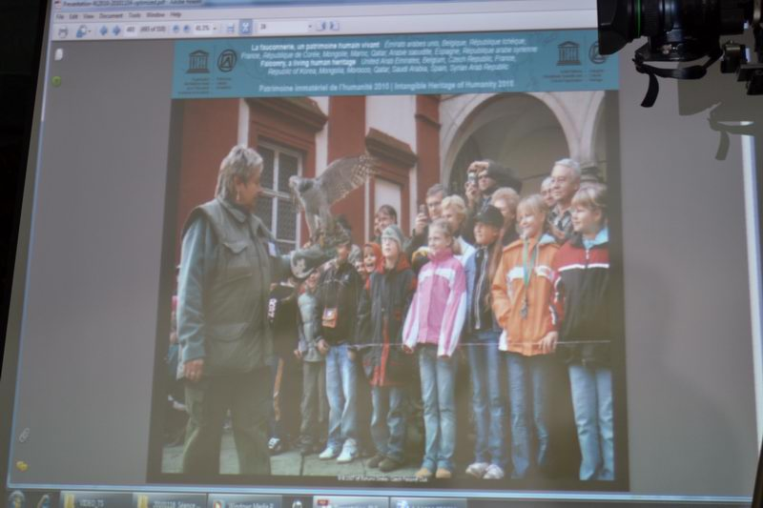  7 | 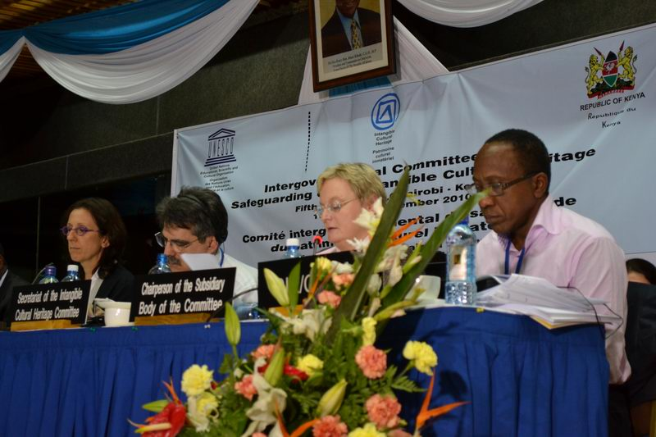  8
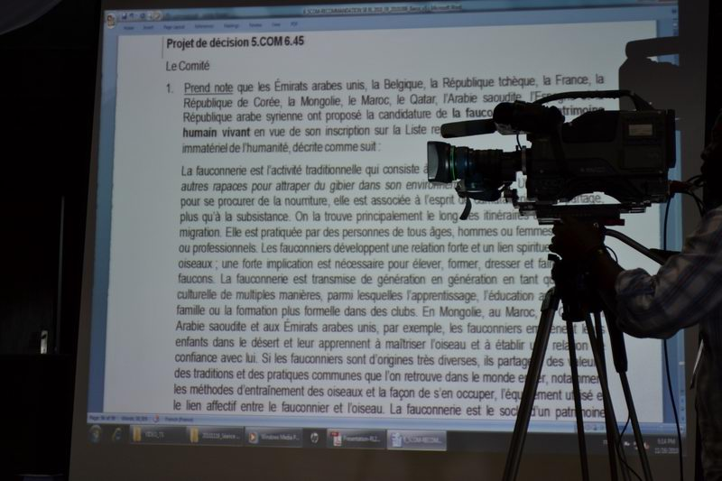  9 | 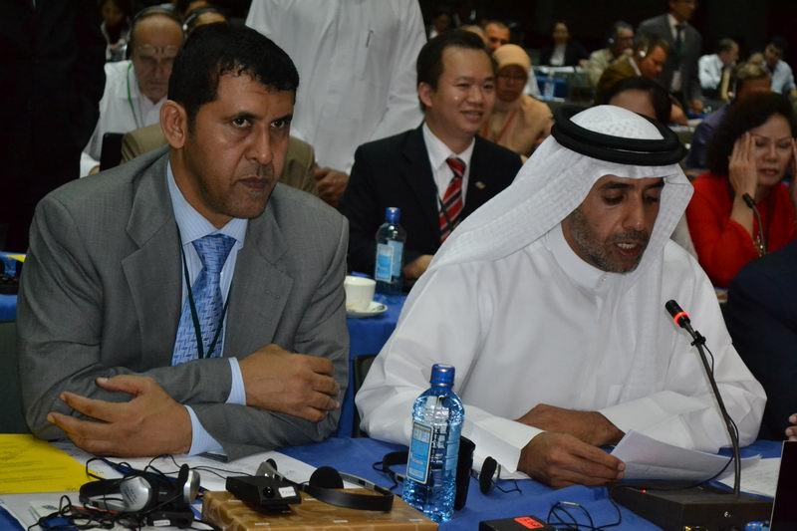  10 | 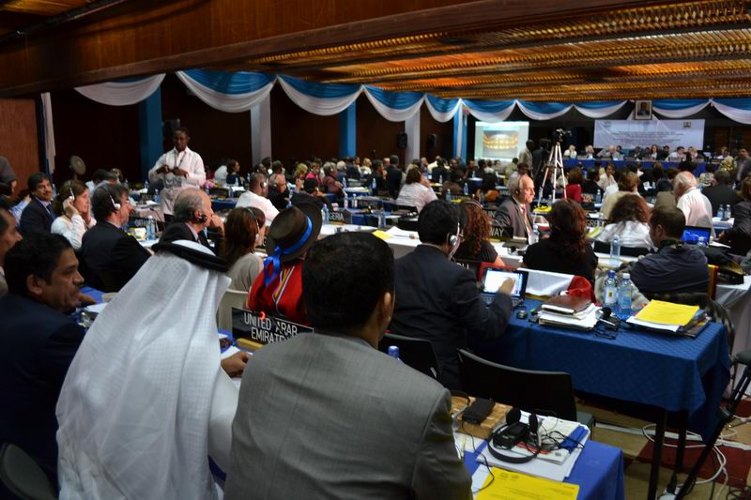  11 | 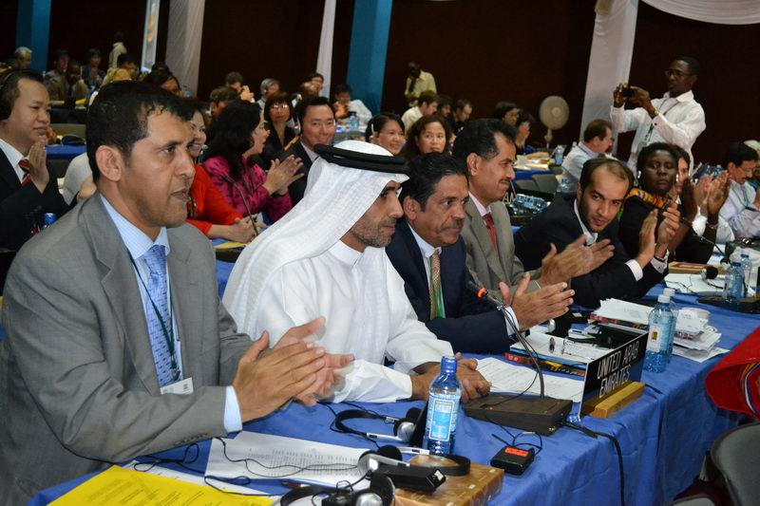  12
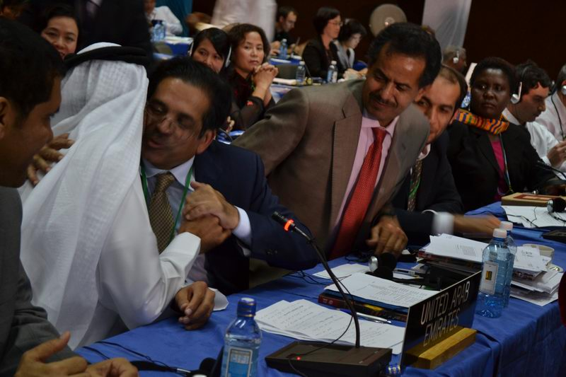  13 | 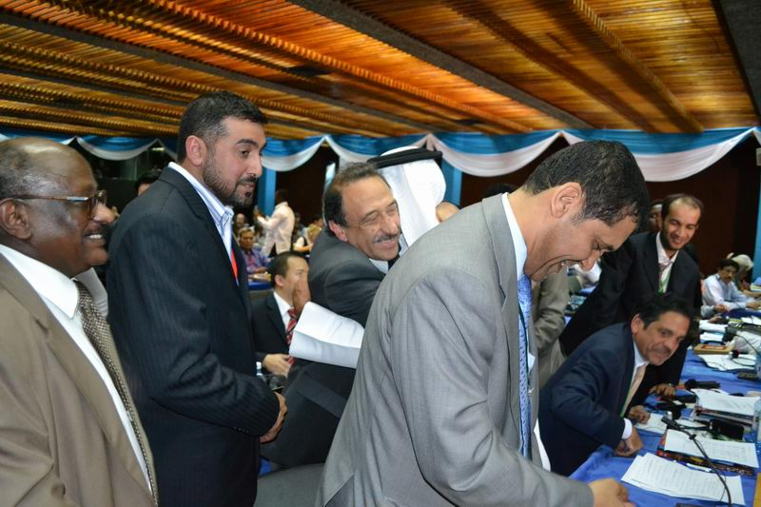  14 | 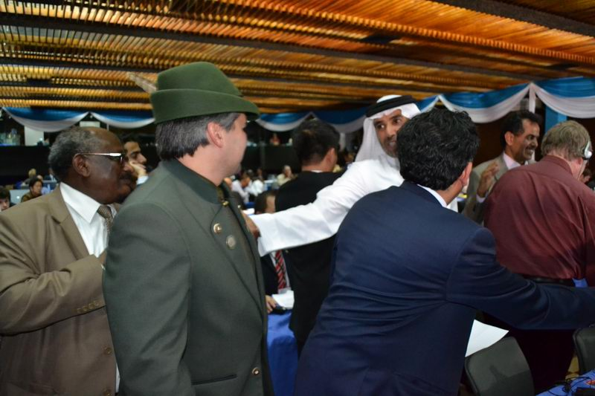  15 | 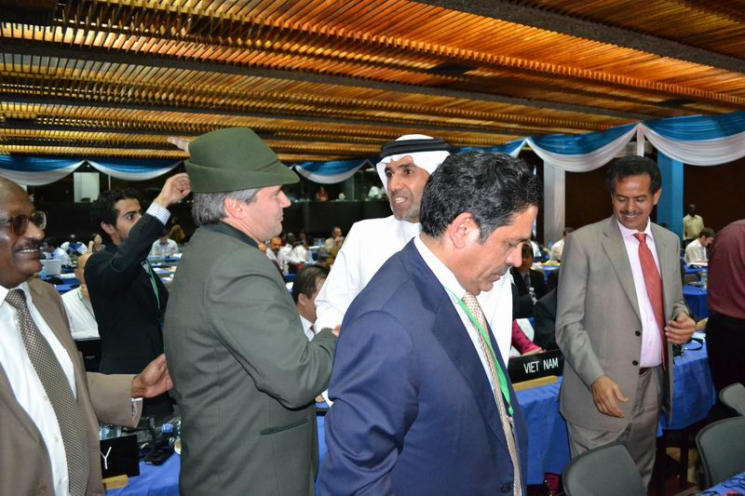  16
Full size photos can be found in the photo directory http://falconer.eu/PHOTO/UNESCO-NAIROBI-NOV2010/
UNESCO session Nairobi, Kenya, November 16th 2010 (time further indicated is local Nairobi time GMT+3)

Photos show the inscription Falconry as the largest nomination in history of UNESCO world heritage list. Falconry is also one of the oldest cultural elements inscribed - e.g. it is even older then famous Egyptian pyramids. 11 countries made the largest multinational nomination: Belgium, the Czech Republic, France, Korea, Mongolia, Morocco, Qatar, Saudi Arabia, Spain, Syria and the United Arab Emirates. From total number of 147 nominations in 2010 from all world, only 2 of them were multinational and only 46 nominations were approved for the final UNESCO list inscription.

1 - 9:39 The Kenyatta International Conference Center (KICC) hall ready for UNESCO session starting at 10:00
2 - 9:45 Experts involved in the nomination in expectations before the session. From the left to right His Excellency Dr. Awadh Ali Saleh Al Musabi - President of the UNESCO committee elected in years 2008-2009, H. E. Mohammed Khalaf Al-Mazrouei - Director General Abu Dhabi Authority for Culture and Heritage (ADACH), Dr. Bohumil Straka - Vice-president International Association for Falconry and Conservation of Birds of Prey (IAF), Dr. Suleiman Khalaf - intangible heritage expert of Syria
3 - 18:10 The best comes at the end... the inscription of Falconry was scheduled at the end of the session after decision on other elements was taken. The secretary is introducing the nomination on one of the oldest cultural elements: "Falconry, a living human heritage"
4 - 18:12 The presentation of the Falconry file is being projected for the delegates
5 - 18:12 Chairperson of the examinators starts to read the results of the evaluation of this large multinational file.
6 - 18:13 Delegation of the United Arab Emirates, leading country of the nomination, is apparently satisfied when evaluation stated that this is: "outstanding example of co-operation between States" and the exemplary quality of the information provided was underlined
7 - 18:13 The presentation of the Falconry clearly demonstrated to the delegates that transmission of this cultural heritage to the new generation is provided, which is essential condition for inscription of any cultural element in the UNESCO list.
8 - 18:14 The Subsidiary body is presenting decision draft
9 - 18:14 The presentation is also presented simultaneously in French language
10 - 18:17 His Excellency Mohammed Khalaf Al-Mazrouei - Director General Abu Dhabi Authority for Culture and Heritage (ADACH) is defending the multinational nomination on behalf of all 11 nominating countries.
11 - 18:18 local Nairobi time, short tension in the hall and the UNESCO delegates approve Falconry for inscription in the list of the world cultural heritage.
12 - 18:19 a big applause...
13 - 18:19 first spontaneous congratulations
14 - 18:19 due to general emotions in the hall, chairman had to tollerate unexpected 10 min. break, while all previous inscriptions continuously followed each other without any emotional gaps.
15 - 18:22 After several minutes, congratulations are still going on
16 - 18:22 Never ending congratulations...

